**UXFT Subject/Module Outline**

|  |  |
| --- | --- |
| **Career Occupation** | Students will graduate the program to fill roles as an entry level, Jr. UX Professional, UX or UI Designer, UX Researcher, Visual Designer etc. |
| **Learning Objectives** | Upon completion of this program, the successful student will have reliably demonstrated the ability to create user-centric digital products within a comprehensive design project cycle. They will conceptualize, wireframe, design, and prototype a high fidelity mobile app prototype along with responsive website designs with leading industry professionals and current software tools. Additionally, students will learn to formulate their own user experience research and strategies, as well as apply design thinking methodologies towards their final project. At the end of the 10-week program, students will have an in-depth understanding of user experience and product strategy, visual and user interface design fundamentals, as well as hard-skills required to create user experience and user interface designs using various software. |
| **Method(s) of Evaluation** | Students are evaluated throughout the 10-week program through regular assignments, labs and in-class presentations. By the end of the program, students would have completed a final project. Feedback is provided on all assignments and presentations. |
| **Completion Requirements** | Students must attend 70% of the classes as defined in the attendance policy and receive a minimum passing grade of 70% in the overall course to be considered to have graduated from the program. |

**Program Organization**

|  |  |  |  |  |  |
| --- | --- | --- | --- | --- | --- |
| **Units** | **# of hours** | **Learning Objective** | **Teaching Method** | **Modules & Evaluation** |  |
| Unit 1: UX Fundamentals | 40 |  |  |  |  |
| Unit 2: UX Research & Strategy | 40 |  |  |  |  |
| Unit 3: IA & App Design | 40 |  |  |  |  |
| Unit 4: Prototyping & Usability Testing | 40 |  |  |  |  |
| Unit 5: Design Sprint Week | 40 |  |  |  |  |
| Unit 6: UI Design & Sketch | 40 |  |  |  |  |
| Unit 7: App Design & UI Library | 40 |  |  |  |  |
| Unit 8: Desktop Website Design | 40 |  |  |  |  |
| Unit 9: Mobile Website Design & UI Library | 40 |  |  |  |  |
| Unit 10: Project Completion | 40 |  |  |  |  |

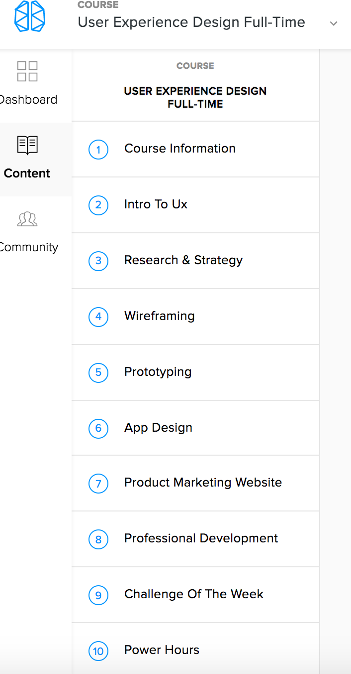

Or archive in Drive

**Intro to UX**

**Research and Strategy**

**Wireframing**

**Prototyping**

**App Design**

**Product Marketing website**

**Professional Development**

Or Course Package Page

### **Unit 1: Design Sprint**

### **Unit 3: Wireframing**

### **Unit 5: Design Sprint**

### **Unit 6: Design Fundamentals**

### **Unit 7: App Design**

### **Unit 8: Final Project - Desktop Site**

### **Unit 9: Final Project - Mobile Site**

### **Unit 10: Professional Development**